Design of Multimodal Adaptive Wireless Control System-MAWCS for Disabled and Elder People

Abstract
This project describes a Multimodal Adaptive Wireless Control System (MAWCS) to help individuals with disabilities and elders with the help of Assistive Robotic Arm (ARA). The described system is capable of supporting multiple nodes in which 3 nodes are used in the system to obtain the upper body gestures and voice commands of user using the wireless sensor body network (WSBN). An Inertial Measurement Unit (IMU) is used to measure the gestures of head and upper body parts, the sensing node is attached to a headset worn. It has a size of 2.9 cm × 2.9 cm, a maximum power consumption of 31 mW, and provides particular angular precision. Similarly muscular activity is measured using surface electromyography (sEMG). Multimodal patch sensor nodes, including both IMU and sEMG sensing modalities are placed over the user able-body parts to measure the motion and muscular activity. These nodes have a size of 2.5 cm × 4.0 cm and a maximum power consumption of 11mW. The proposed BoMI runs on a Raspberry Pi. It can adapt to several types of users through different control scenarios using the head motion, voice commands of the user as well as muscular activity, and provides a power autonomy of up to 24 hours. The users can perform all tasks with the proposed MAWCS and ARA, almost as fast as with the Mobile application, with only 30% time overhead on average, while being potentially more accessible to the upper-body disabled who cannot use the conventional joystick controller. It can also be controlled using the voice commands of the user in case of a totally paralysed patient.

Introduction:
The disabled people have improved their functional capacities over the past recent years due to the advancement in assistive technology and rehabilitation engineering. To maintain residual capacities of disable users in their activities of daily life (ADLs), a rapid of assistive devices have emerged worldwide. The quality of life can be potentially enhanced by introducing the assistive technology, some of the core QOL domains: emotional wellbeing, interpersonal relationships, material well-being, personal development, physical wellbeing, self-determination, social inclusion and rights [1] While technologies such as hearing aids, retinal implants and haptic feedback systems, etc aim at providing or restoring apprehension abilities. The ideal binary mask is one algorithm speciﬁcally shown to improve speech intelligibility. The speech intelligibility scores reported by normal hearing listeners increased from 12% to 100% after speech embedded in four-talker babble was processed by the ideal binary mask. Similarly, the ideal binary mask improved speech intelligibility from nearly 0% to 100% in the study described in [2]–[4]. Mobility aids (intelligent wheelchairs, prosthetic devices and other domestic appliances such as robotic manipulators) require a voluntary user interaction based on their residual functional capacities (RFC’s). The main purpose of the proposed orientation control system is to enhance the users’ experience by enabling them to control the robot with more performance and intuitiveness. The first priority of robotic devices is safety, they must also be intuitive and efficient from an engineering point of view in order to be adopted by a broad range of users. [5]–[8]. . Even though extrinsic enablers among the latter category are game changers and contribute to users’ quality of life (QoL) improvement, the lack of readily available and affordable adaptive controllers limits their efﬁciency and adoption rate by people living with severe disabilities [9]. Tools such as switch devices, dedicated keypads, mice, trackballs, joysticks, head and hand pointers, sip-and-puff tools, mouth sticks or lip control systems [10]- [11] require a mechanical intervention from the users, which can be obtrusive and drain physical resources of severely impaired users. Smart and unobtrusive Body-Machine Interfaces (BoMIs) have been designed based on latest technologies for easing interaction with assistive devices by exploiting users’ RFCs. Computer vision with 3 dimensional (3D) cameras has been explored to detect and reach/grab objects [12], [13]. Similarly, in [14], eye tracking is used to infer human intents, detect objects and control an AT device in 3D. Brain-computer interfaces (BCI) using EEG [15] and/or electrocorticography (ECoG) [16] have also been designed and tested, but although they achieved promising results, this category of BoMI can remain difficult to operate without extensive training, or be very invasive when they are requiring a physical connection to the actuating organs, through electrodes, for instance [17].
In order to operate robotic arms and motorised wheelchairs, non-invasive and wearable controllers based on Electrooculography (EOG) have been implemented successfully.[18]-[19].
In order to translate user’s residual muscular activity into commands, surface electromyography was used; these activities are identified by robust detection and pattern recognition techniques. Along with the systems that are based on electrophysiological signal measurement, there are different types of BoMI which work on the residual natural body motion sensing have been designed [20-21]. In [28], a multimodal interface combines head motion, speech recognition to control a computer. The combination of sEMG, eye-tracking and EEG is proposed in [29] to manipulate a prosthesis with high dexterity. Such approaches are deemed to provide many more degrees of freedom (DoF) then unimodal control systems, opening up the possibility of harnessing more potential control strategies better suited to each individual user [30]. A multimodal BoMI based on an adaptive wireless control system (AWCS) is developed for people living with upper-body disabilities. Already, the concept of 2D BoMI prototype has been proved. It has three nine-degree-of-freedom (9-DOF) inertial measurement units (IMUs) connected to a microcontroller and help measuring the user’s head and shoulders position, using a complementary filter approach. The results are then transmitted to a base-station via a 2.4-GHz low-power wireless transceiver and interpreted by the control algorithm running on a PC host [31]. Now, in this paper, a complete 3D BoMI based on AWCS running on a Raspberry Pi (RPi) is presented.

AUDIO MODEL

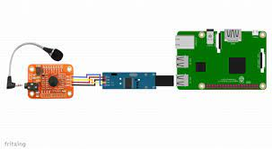
Figure 1 Audio Model

A. Requirements
In MAWCS, first adaptive model is voice model. Generally, the agenda of MAWCS, is to help the disability persons. This audio model helps the disable persons to operate the arm by voice commands. This model consists of Raspberry pi, motor shield, servo motor, mic. The voice commands of the user are identified using a Voice Recognition Module compatible to the Raspberry pi.

B. Functional Description
The proposed control interface exploits the user's voice through mic. Those voice signals are identified by the use of Voice Recognition Module which can be trained as per the user’s requirements and transmitted by the help of a trans receiver to raspberry pi, since the connection between module and raspberry pi is wireless.
The received signals are compared with the predefined voice commands which are already fed in raspberry pi, and after finding the command it moves the respective joint of the arm with the help of motor shield.

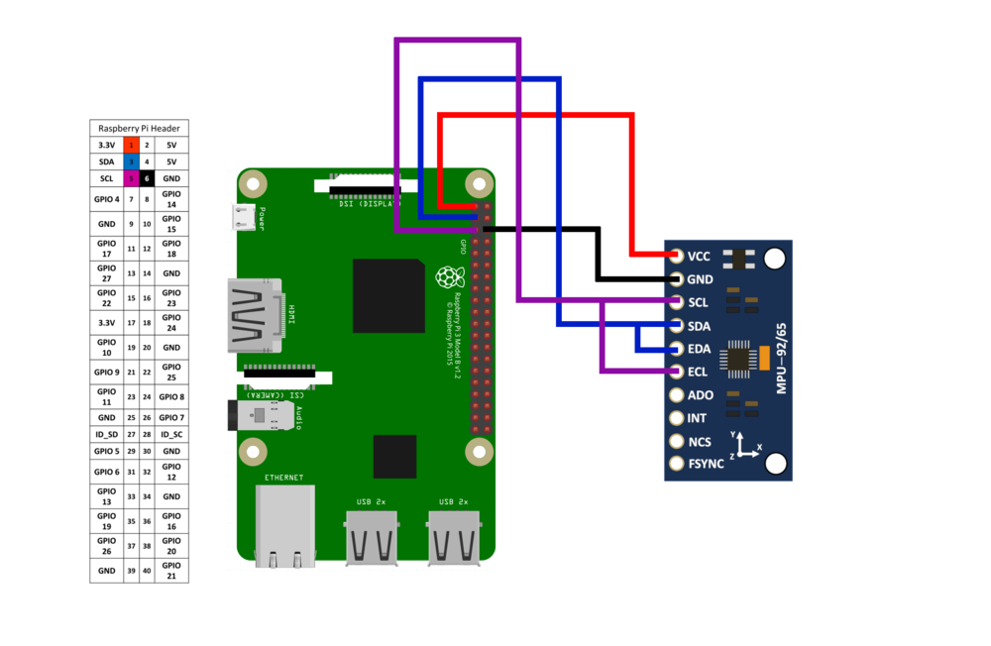
Figure 2: IMU Model

ADAPTIVE MODEL – 2

A. Requirements
In MAWCS, second adaptive model is the Inertial model. Generally, the agenda of MAWCS, is to help the disability persons. This Inertial model helps the disable persons to operate the arm by Head Motion. This model consists of Raspberry pi, motor shield, servo motor, MPU6050 IMU Sensor.

B. Functional Description
The proposed control interface exploits the user's Head Movements through IMU Sensor. Those Inertial signals are converted to electromagnetic waves and transmitted by the help of a trans receiver to raspberry pi, since the connection between IMU Sensor node and raspberry pi is wireless. The received signals are analysed in raspberry pi which consists of angular momentum of the head and thereby moving the motors in the hand respectively with the help of a motor Shield.
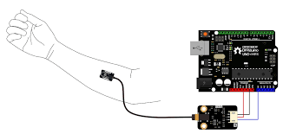
Figure 3: sEMG model

ADAPTIVE MODEL – 3

A. Requirements
In MAWCS, the third adaptive model is to capture signals produced by contraction of muscles using a Myoware sEMG Sensor. Generally, the agenda of MAWCS, is to help the disability persons. This model helps the disable persons to operate the arm by contraction of their own hands. This model consists of Raspberry pi, motor shield, servo motor, sEMG Sensor.

B. Functional Description
The proposed control interface exploits the user's Muscle Movements through sEMG Sensor. Those electromagnetic waves from the sensor are transmitted by the help of a trans receiver to raspberry pi, since the connection between sEMG Sensor node and raspberry pi is wireless. The received signals are analysed in raspberry pi which consists of a muscle movement and thereby moving the motors in the hand respectively with the help of a motor Shield.

REFERENCES
[1] L. Dark, Assistive Technologies for People With Diverse Abilities. New York, NY, USA: Taylor & Francis, 2014.
[2] V. Hanson and K. Odame, “Real-time embedded implementation of the binary mask algorithm for hearing prosthetics,” IEEE Trans. Biomed. Circuits Syst., vol. 8, no. 4, pp. 465–473, Aug. 2014.
[3] A. Bhowmick and S. M. Hazarika, “An insight into assistive technology for the visually impaired and blind people: State-of-the-art and future trends,” J. Multimodal User Interfaces, vol. 11, no. 2, pp. 149–172, 2017.
[4] D. T. Pawluk, R. J. Adams, and R. Kitada, “Designing haptic assistive technology for individuals who are blind or visually impaired,” IEEE Trans. Haptics, vol. 8, no. 3, pp. 258–278, Jul./Sep. 2015.
[5] I. P. Ktistakis and N. G. Bourbakis, “Assistive intelligent robotic wheelchairs,” IEEE Potentials, vol. 36, no. 1, pp. 10–13, Jan./Feb. 2017.
[6] D.-S. Vu, U. C. Allard, C. Gosselin, F. Routhier, B. Gosselin, and A. Campeau-Lecours, “Intuitive adaptive orientation control of assistive robots for people living with upper limb disabilities,” in Proc. Int. Conf. Rehab. Robot., 2017, pp. 795–800.
[7] D. A. Bennett, S. A. Dalley, D. Truex, and M. Goldfarb, “A multigrasp hand prosthesis for providing precision and conformal grasps,” IEEE/ASME Trans. Mechatronics, vol. 20, no. 4, pp. 1697–1704, Aug. 2015.
[8] H.Parketal.,“ A wireless magneto resistive sensing system for an intraoral tongue–computer interface,” IEEE Trans. Biomed. Circuits Syst., vol. 6, no. 6, pp. 571–585, Dec. 2012
[9] A. M. Cook and J. M. Polgar,Assistive Technologies: Principles and Practice. Amsterdam, Netherlands: Elsevier Health Sciences, 2014.
[10] Kinova Robotics Canada. Picture: Jaco arm mounted on a powered sheelchair. [Online]. Available: http://www.kinovarobotics.com/assistiverobotics/products/robot-arms/. Accessed on: Mar. 19, 2018.
[11] M. A. Jose and R. de Deus Lopes, “Human–computer interface controlled by the lip,” IEEE J. Biomed. Health Inf., vol. 19, no. 1, pp. 302–308, Jan. 2015.
[12] H. Jiang et al., “A machine vision-based gestural interface for people with upper extremity physical impairments,” IEEE Trans. Syst., Man, Cybern., Syst, vol. 44, no. 5, pp. 630–641, May 2014.
[13] H. Jiang, T. Zhang, J. P. Wachs, and B. S. Duerstock, “Enhanced control of a wheelchair-mounted robotic manipulator using 3-d vision and multimodal interaction,” Comput. Vis. Image Understanding, vol. 149, pp. 21–31, 2016.
[14] S. Chandra et al., “Eye tracking based human computer interaction: Applications and their uses,” in Proc. IEEE Int. Conf. Man Mach. Interfacing, 2015, pp. 1–5.
[15] A. S. Royer, A. J. Doud, M. L. Rose, and B. He, “EEG control of a virtual helicopter in 3-dimensional space using intelligent control strategies,” IEEE Trans. Neural Syst. Rehab. Eng., vol. 18, no. 6, pp. 581–589, Dec. 2010
[16] A. Rouse et al., “Spatial co-adaptation of cortical control columns in a micro-ECOG brain–computer interface,” J. Neural Eng., vol. 13, no. 5, 2016, Art. No. 056018.
[17] C. E. Bouton et al., “Restoring cortical control of functional movement in a human with quadriplegia,” Nature, vol. 533, no. 7602, pp. 247–250, 2016.
[18] A. Ubeda, E. Ianez, and J.M.Azorin, “Wireless and portable EOG-based interface for assisting disabled people,” IEEE/ASME Trans. Mechatronics, vol. 16, no. 5, pp. 870–873, Oct. 2011.
[19] Q. Huang et al., “An eog-based human-machine interface for wheelchair control,” IEEE Trans. Biomed. Eng., 2017.
[20] C. L. Fall et al., “Wireless sEMG-based body–machine interface for assistive technology devices,” IEEE J. Biomed. Health Informat., vol. 21, no. 4, pp. 967–977, Jul. 2017.
[21] U. Cotˆ e-Allard, C. L. Fall, A. Campeau-Lecours, C. Gosselin, F. ´ Laviolette, and B. Gosselin, “Transfer learning for sEMG hand gestures recognition using convolutional neural networks,” in Proc. 2017 IEEE Int. Conf. Syst., Man, Cybern., 2017, pp. 1663–1668.
[22] H. Park et al., “A wireless magnetoresistive sensing system for an intraoral tongue-computer interface,” IEEE Trans. Biomed. Circuits Syst., vol. 6, no. 6, pp. 571–585, Dec. 2012.
[31] C. L. Fall et al., “A multimodal adaptive wireless control interface for people with upper-body disabilities,” in Proc. 2017 IEEE Int. Symp. Circuits Syst., 2017, pp. 1–4

